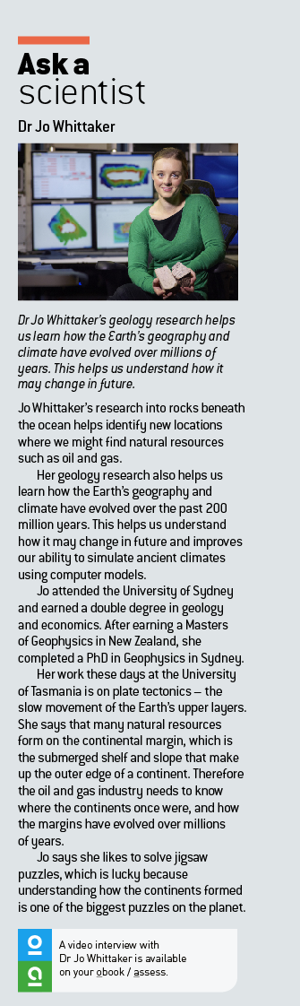Ask a scientist worksheet

2.9 Rocks are studied by geologists

Pages 34–35

Dr Jo Whittaker – geologist

1 What does Jo study and where does she work?

_________________________________________________________

_________________________________________________________

2 The steps below describe the changes that occurred over millions of years as Gondwana changed and the continents formed. Number these steps in the correct order.

|  |  |
| --- | --- |
| Step | Description of change |
|  | India begins to move away |
|  | Himalayas are created |
|  | India, Australia and Antarctica all form Gondwanaland |
|  | The Indian Ocean forms |

3 What data does the ship collect on its month-long voyages?

__________________________________________________________

__________________________________________________________

4 What can the data collected by the ship tell us about the environment millions of years ago?

_________________________________________________________

_________________________________________________________

5 How could the lessons of 35 million years ago help modern scientists understand climate change better?

6 Name two reasons why Jo enjoys her role as a geophysicist.